Project Design Phase
Solution Architecture
Date | 23 September 2026
Team ID | SWTID-2026-9317
Project Name | AI BlogNest – AI-Powered Blog Management Backend
Maximum Marks | 4 Marks
Solution Architecture:
AI BlogNest uses a layered backend architecture that bridges blog-management requirements with AI-assisted content services. The architecture defines the major components, their responsibilities and the flow of data between the client, backend services, AI service and database.
Architecture Goals:
- Provide a suitable backend technology structure for blog management and AI-assisted content operations.
- Describe the structure, behavior and data flow of the AI BlogNest system.
- Define the main services, features and development requirements.

Component | Responsibility
User / Admin | Interacts with the blog application and performs content-management operations.
- Provide a clear specification for implementing, managing and delivering the solution.
Architecture and Data Flow Diagram:
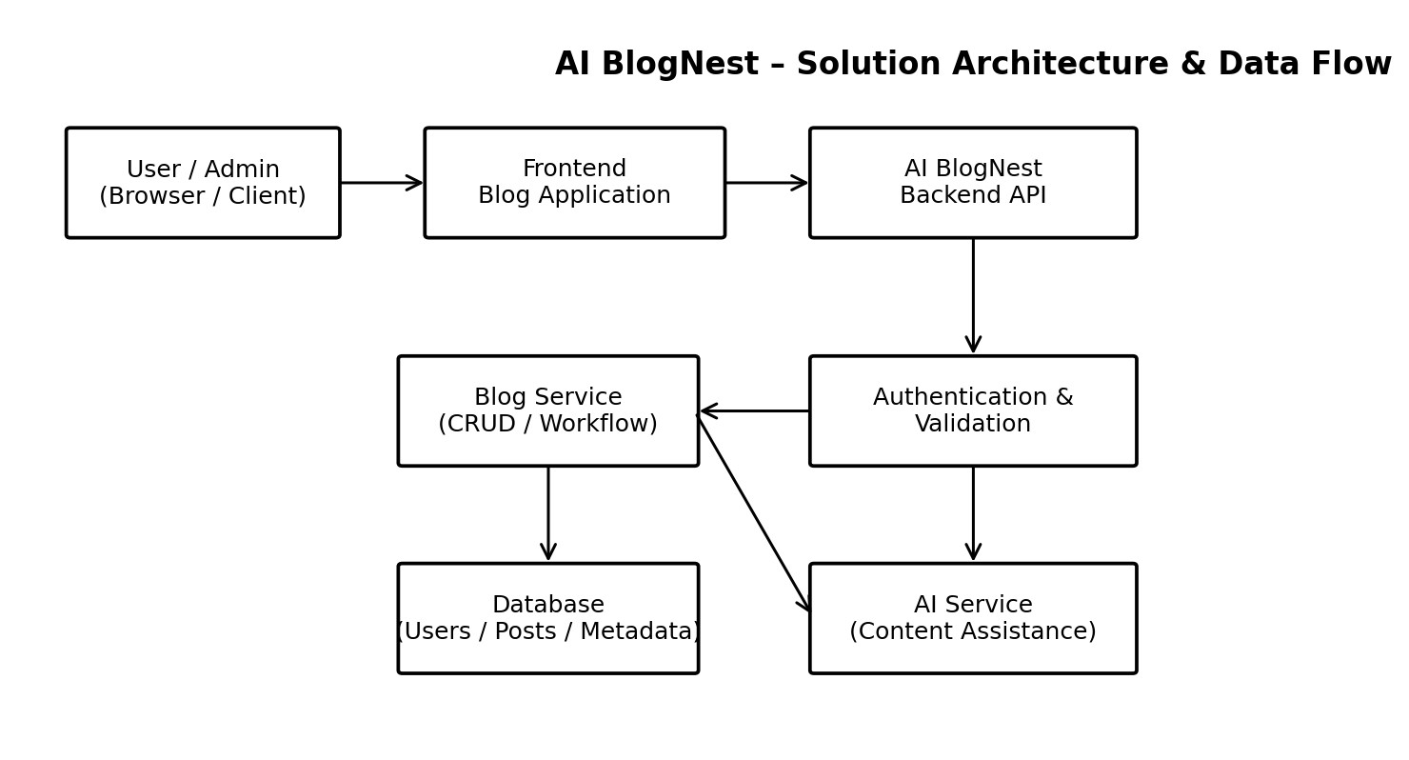
Figure 1: Architecture and data flow of the AI BlogNest application
Architecture Components:
Component | Responsibility
Frontend | Provides the user interface and sends requests to the backend API.
Backend API | Central service layer that receives requests, applies application logic and coordinates other services.
Authentication & Validation | Validates requests and controls authorized access to backend operations.
Blog Service | Handles post creation, retrieval, update, deletion, organization and publishing workflow.
AI Service | Provides AI-assisted content generation, improvement or other content-related operations.
Database | Stores users, blog posts, categories/tags, metadata and application data.
Data Flow:
User/Admin → Frontend → Backend API → Authentication & Validation → Blog Service / AI Service → Database → Backend Response → Frontend → User/Admin.
Reference:
Architecture structure adapted from the supplied Solution Architecture template.

